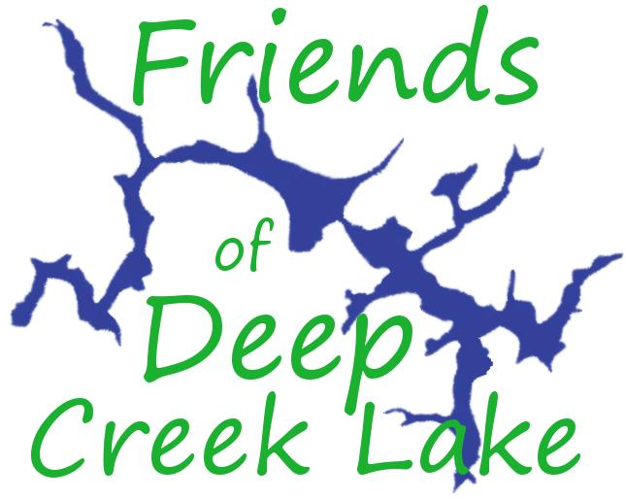
POSITION ON HYDRAULIC FRACTURING
Adopted by Board of Directors,
December 10, 2016
date

We, the Board of Directors of Friends of Deep Creek Lake, affirm our organizational mission “to promote conservation, stewardship and restoration of Deep Creek Lake and its watershed”. Over 8 years of operation we have defined our organizational mission as covering the lake and watershed as a natural resource, ecological system, recreational resource, backbone of the county and regional economy and, the hardest to quantify, source for lake-based quality of life for our families, friends and future generations.
The lake is located in the Marcellus Shale basin. If the State of Maryland were to permit hydraulic fracking, we anticipate a range of negative impacts on the lake and watershed, as shown in scientific research and experiences in other areas where fracking has taken place.
The Maryland General Assembly will consider bills on fracking in the upcoming session, in anticipation of the end of the current fracking moratorium, which ends October 1, 2017.
After considerable research and active participation in the fracking date, at this point in time, we has determined that our mission leads us to voice a position challenging whether proposed regulations for hydraulic fracturing will provide the protection of the lake and watershed from projected negative impacts resulting from fracking in the DCL watershed and the County.
We are mindful that as a non-profit organization, we cannot actively engage in lobbying to support any specific bill in the General Assembly session. We can, however, provide information and education to lake stakeholders which will enable them to become in advocates. Further, we have a unique role and responsibility to share the voices of Deep Creek Lake property owners in the upcoming debate.

The policy framework which has led the
Board of Friends of Deep Creek Lake to adopt this position.
At the County level--- DCL Zoning Ordinance
There is zoning for the lake and watershed which is detailed in the DCL Watershed Zoning Ordinance. Responding to a petition from lake business owners, the County Planning Commission has recommended the following be added to list of land uses not permitted in the watershed: “natural gas associated infrastructure equipment”. The next step is for the Board of County Commissioners to consider and vote on this Planning Commission recommendation. As of our decision, there is no indication when the Commissioners will act on this matter.
This is a land-use recommendation. If the County Commissioners were to adopt the recommendations, subsurface drilling from wellheads abutting the watershed will be allowed.
It is also limited to just protection of the natural resource. However, the lake does not exist in a “bubble”, the industrialization of the area by fracking would have extensive impacts in the whole county, impacting lake property owners and our enjoyment of this region.
No County-wide zoning.
If there were zoning in the whole county, the Board of Commissioners could apply the land use prohibition throughout the county and thereby prevent all siting of well-heads, which would address the major loop-hole under consideration for the DCL Zoning Ordinance.
Economic impacts of fracking.
For 5 ½ years Friends of DCL has requested data on economic impact of fracking on our resort-based economy and on specifically on lake properties? No study has been undertaken to provide answers to this basic question.
By the end of December, the County will hire a firm to undertake such analysis. Unfortunately the report of this work is projected to be released in the spring, after the General Assembly has to act.
At the State level—Maryland Department of Environment Proposed Regulations for fracking.
Maryland Department of Environment has been tasked by the General Assembly with development of regulations for the fracking industry. The goal of these regulations is to provide protection to “the public health, safety, the environment and natural resources”.
After careful study and recent public hearings held by MDE, we have found the draft regulations lacking.
The regulations submitted to the General Assembly do not make necessary changes for DCL and watershed protection. 1) DCL is now listed as a restricted area but, like the County approach, is only for land use purposes, not subsurface drilling; 2) There are no protections for Deep Creek Hydro though protections for dam integrity are of critical importance in a fracking zone. 3) The compliance, enforcement and funding component is still weak and given our experiences on other fronts with MDE compliance of deep concern. 4) There is no provision for on-going water monitoring and no monitoring of air quality. Therefore, we must conclude that the MDE regulations as presented to the General Assembly will not provide necessary protections.
Therefore, the only option to provide protection from negative impacts of fracking on Deep Creek Lake and its watershed is to support legislative action to prevent hydraulic fracturing in Maryland.
Further this action must take place this year due to the strong pro-fracking position of the Trump administration.

Friends of Deep Creek Lake has a solid background on community education and research on the potential impacts of Marcellus Shale exploitation on the lake, watershed and county.
- DCL and Marcellus Shale Drilling Forum, August, 2011, a non-partisan panel attended by over 125 people. (Video available)
- Since 2012, Friends of DCL volunteers have participated in the Marcellus Shale Water Monitoring program led by DNR. This work evolved from our on-going Stream Wading field monitoring of lake tributaries. We have sampled Cherry Creek and Shingle Camp Stream—the two tributaries identified by DNR as potential areas of concern if fracking were to be allowed. We were recipient of the Clarence Johnson Award for this work.
- “Fracking Western Maryland?” Film and panel, July 2016. In addition to viewing the film, almost 100 attendees heard presentations addressing theme of “What Next” with 7 presentations from people working on fracking issue. (Video available.)
- Presentation at the Maryland Sierra Club Forum, July 2016, attended by 50 people, many who were lake stakeholders.
- We have also continued to provide our newsletter recipients updates on both science and regulation as well as update on events and links to organizations working on this issue.
- Conducted several versions of a Survey entitled “To Frack or not to Frack” which probed for respondents’ position on fracking (vast majority support ban at state level) and how FoDCL should be engaged in the issue ( most supported active involvement and linking to other groups working on issue. ).
- Ellen Williams and Barbara Beelar testified at MDE hearing on regulations. FoDCL hired videographer to film hearing. No editing or posting of the hearing has been done.
- Barbara Beelar was asked by the Committee on Environment and Transportation to represent the lake stakeholder perspective at the recent Working Session hosted by these delegates.
- FoDCL hosted boat tour of DCL for visiting delegates, with a stop in Cherry Creek to point out area of the lake must vulnerable to fracking, if it is permitted in the state. (Video available)
- Ellen Williams and Barbara Beelar attended a meeting of local groups to explore avenues for collaboration and have continued conversations with both state and local groups working on fracking issues.

How adoption of the Board position on fracking will guide our Work Plan

- Preliminary guidelines defining scope of work, drawn from discussion of August, 2016 Board meeting.
- FoDCL will work to ensure the voices of lake stakeholders are heard in the upcoming discussions as way of achieving organizational mission.
- FoDCL will not take a leadership role.
- FoDCL will be mindful that any involvement does not undercut or compromise achievement of other work to achieve our goals.
- FoDCL will continue its collaborative relationship with both local and state wide organization working on fracking and will be sure that perspective of lake stakeholders is incorporated in this work.
- FoDCL will be mindful of its limited resources and staffing and not undertake initiatives in this area without additional support.

- FoDCL projected Scope of Work
- Continue to provide information on science, legislative and regulatory matters at both State and County level, updates on events and links to organizations working on the issue.
- Friends of Deep Creek Lake will continue to sample Cherry Creek and Shingle Camp as part of the Marcellus Shale Water Monitoring Project.
- Friends of Deep Creek Lake will continue to provide high quality analysis of issue relating to fracking and the DCL watershed.
- Friends of DCL will continue push for full, comprehensive analysis of the impacts of fracking on our resort based economy with particular focus on impacts on lake property, recreational enjoyment, and quality of lake living matters. And, until such a report is available and reviewed, FoDCL will provide data and analysis to keep these issues on the forefront of the discussion in Annapolis.
- FoDCL will develop a fracking inform/engage campaign for lake property owners interested in expressing their views in the coming months. This campaign will build an email list of such individuals and provide them with information and tools to enable them to effectively communicate their views. FoDCL will continue to seek funds to conduct a professional opinion poll of lake property owners.

